Case Study – Compostable Packaging Project

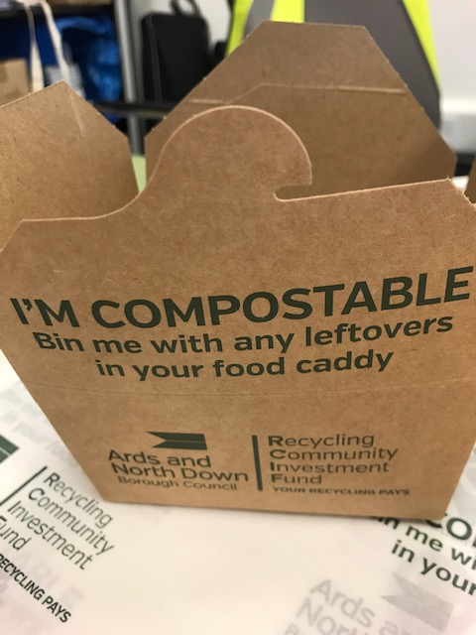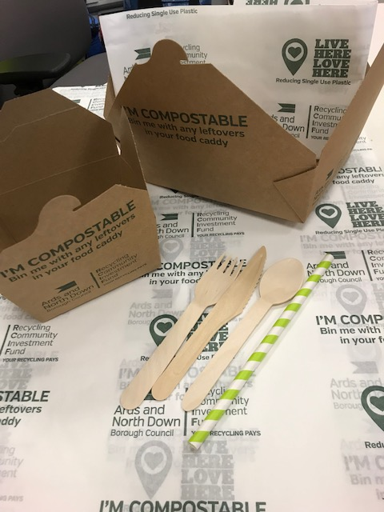

Project name/title | Compostable Packaging Project
Project contact | Alison Curtis – Waste Resources and Contracts Manager
Project summary | Encourage local businesses to reduce use of single-use plastic items by trialling compostable items and educating customers on issues of single-use plastics and proper disposal of compostable items. 50 businesses were targeted, launched after businesses had recently switched to fortnightly bin collections, to help reduce black bin waste. Businesses were required to put poster in their window / on their counter throughout trial, complete a pre and post survey regarding their thoughts and experience as well as their customers’ feedback. The range of compostable items were paper straws, small food box, large food box, greaseproof paper, wooden knives, forks, spoon. Businesses able to choose items most appropriate for their work.
Aims/objectives of project | - To raise awareness of issues of single-use plastic with local businesses and customers  - To reduce black bin waste  - To improve sustainability  - To instil behaviour change in businesses and customers regarding single use items
Funded by | Recycling Community Investment Fund (RCIF) & Live Here Love Here (DAERA)
Cost | - Custom print cost of items with RCIF & Live Here Love Here logo and clear instructions of how to dispose  - Compostable items (including small food box, large food box, cutlery, greaseproof paper and straws) approx. 250 of each item for 51 businesses  - Promotion materials  - Total costs: £7,416.77
Increases in recycling or reduction targets if any | - For the period of the trial single-use items used in the 51 businesses was reduced to zero with the aim of reducing some if not all single-use items for businesses that aim to continue. From the 51 businesses who took part, 19 completed the post survey and 90% said their businesses had benefitted from the items, based primarily on customer feedback. Food boxes were the most useful. All bar 1 said they would use the items in the future.
Target audience | Businesses and general public in the Ards & North Down area
Successes | - Significant reduction in single-use items used in 51 business across Ards & North Down for the duration of the trial and potentially beyond  - Raised awareness of issues with single-use plastics among businesses and customers  - Raised awareness of alternatives to single-use plastic items among businesses  - Strong uptake and positive response from nearly half the businesses  - Great coverage for all involved by BBC Conor McAuley
Barriers | - Perceived and actual costs are still deamed as high  - Time intensive to engage with businesses
Any communications inhouse or external (eg:- press releases, photos, social media, links to your organisations website) | - Posters & literature on Recycling Community Investment Fund and Live Here Love Here  - Pre and post surveys for businesses  - Interdepartmental project  - Social media  - BBC TV coverage  https://www.bbc.co.uk/news/av/uk-northern-ireland-48760751/plastic-pollution-stemming-the-tide-on-ni-s-beaches
Other observations | - Money is a key barrier  - Suppliers need to reduce costs/more businesses use, costs will come down  - Businesses need some kind of incentives to bridge the gap

