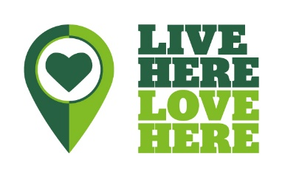
Tackling Plastic: Single-Use Plastic Audit Form
You can change this template to suit your business. Record all single-use plastic items your business uses, as a baseline to work from in the ‘Before’ section. This will give you an idea of your current plastic usage. When you’ve completed the ‘before’ section, go to the action plan. Once you have taken action, complete the ‘After’ section to see your improvement. This form can be copied and reused as often as is necessary for your business.
Date Started: Completed by:
Items | Before |  |  |  | After
This is not an exhaustive list, just some examples to help you get started. | Quantity used  (in 1 month) | Prioritise*  1= most important | Responsibility  of | Initial thoughts on action stop using/purchasing item; reduce use by a specific percentage; find an alternative | Quantity used | Difference  % reduction – aim for 100%
Staff lunches/breaks:
Plastic bottles
Plastic food packaging
Coffee cups
Plastic bottles
Extrapolate findings (annual figures)
Catering (internal & external events):
Plastic bottles
Coffee cups
Plastic cups
Spoons, knives, forks, stirrers
Straws
Plates/ trays
Polystyrene takeaway containers
Jam, sauces, other condiments
Extrapolate findings (annual figures)
Cleaning:
Plastic cleaning cups
Individual hand soaps
Plastic bags
Plastic gloves
Extrapolate findings (annual figures)
* Choose which items you’re going to address in order of priority 1=most important.

