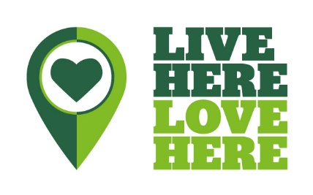
Tackling Plastic: Single-Use Plastic Action Plan
Date range of this plan:
Action | Target | Timescale/ Deadline | Responsibility | Evaluation
What are we going to focus on and what action are you going to take? Detail needed here.  (From the Audit Form pick at least 3 items your business will focus on) | What is your target? Quantifying will help give you great statistics for social media  – stop using / purchasing item  – reduce use by a specific percentage  – choose an alternative | Set yourself goals, have some easy wins, where you know you can make a difference with little effort and then longer goals for this which will take a bit more time | Which member of your team is in charge? | When the After section of the audit is complete you can use it to complete this evaluation. Was the action successful or not successful? How can we build on this for the future?  Repeat this process as you continue on your reducing plastic journey.
For example, Catering:
Encourage staff and customers to bring reusable or stop using some items.
Find suppliers who use alternative packaging.
Ask suppliers not to provide single-use plastic at external events/ not to send items in plastic any more.
Find alternative providers who use less plastic packaging
For Staff Lunches/breaks:
Providing alternatives (ceramic cups/glasses)
Have water refill stations/glass bottles to keep water cooled in the fridge instead of having water coolers
Encouraging the use of reusable
For example, Cleaning Supplies: Purchase larger containers
Find alternative providers for cleaning supplies with more lines of recycled goods

