Green Flag Community Application Guidance 2022

The Green Flag Community Award® is the national award recognising high-quality green spaces managed by voluntary and community groups.
The award is managed locally by Keep Northern Ireland Beautiful as part of the Green Flag Award® scheme.

Who is eligible to apply for the award:
All community green spaces that are easily accessible and open to the public (i.e. accessible to users during the day where no key/code is needed for entry). These include but are not limited to:
• Community gardens
• Woodlands
• Nature reserves
• Allotments
• Churchyards

Applications open on 13th December 2021 and will close on 14th February 2022.
Judging will commence in May 2022.
The award is given on annual basis and winners must reapply for their Green Flag status each year.

How to apply:
Step 1: You will need to create an account on the Green Flag website. To do this, please go to Organisation Summary (greenflagaward.org)
Step 2: Scroll to the bottom of the page and fill in the details under ‘Apply for an Award’
You will be emailed your login details on completion. If you do not receive these within 48 hours, please contact Cara at cara.johnston@keepnorthernirelandbeautiful.org

Completing your application:
When you have been emailed your log in details, please complete the following steps:
Step 1: Sign into your Green Flag account here
Step 2: Complete each of these sections. You can save your progress as you go along.

Documents you will need to provide
Your local council may be able to help you with retrieving these documents.
- Management plan for your site
Please use the template emailed to you with your log in details

- Constitution for your site
This can be terms the group agree to abide by e.g. how often you meet.

- Lease for your site
A letter/email from the landowner/council will be accepted

- Insurance for your site

Optional documents to support your application
- Site risk assessment
- Map of the site
- Deeds of the site
- Photographs

Please note that you can still apply despite not all documents being submitted. Depending on which documents are missing, we may need to contact you for further information.
If you have difficulty filling out any of the application, please email Cara at cara.johnston@keepnorthernirelandbeautiful.org

Why get involved?
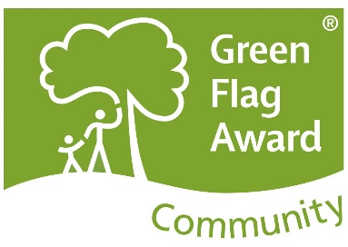
- Gain a national quality standard for your green space
- Get recognition for the hard work put in by your group
- Benefit from publicity of your site through social media pushes and press releases
- Increase your site’s prospects of securing grants
- Receive feedback and recommendations following the judging process for enhancing your site
- Gain a flag to showcase your Green Flag status

