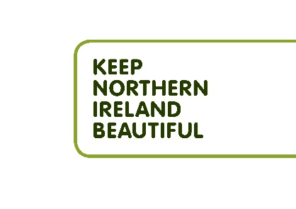
Roles and Responsibilities
Keep Northern Ireland Beautiful

General Information
Job Title | Green Flag Project Officer – Maternity Cover
Employed by | Keep Northern Ireland Beautiful
Reporting to | Local Environmental Quality (LEQ) Manager
Job Purpose | Provide programme support for the Green Flag for Parks & Open Space programme
Hours of Business | Core hours 9am - 5pm
Location | Home/office and field-based
Hours per week | 37.5
Salary | £26,000
Term | Temporary until 31st March 2022 (possible extension subject to funding)  INTERVIEWS Monday 5th December 2022
JOB PURPOSE
The Green Flag for Parks & Open Spaces programme recognises and rewards well managed parks and green spaces, setting the benchmark standard for the management of recreational outdoor spaces across the United Kingdom and around the world.
The Green Flag for Parks & Open Spaces Officer will provide hands-on support to grow the programme in Northern Ireland, empowering communities to make a positive impact in their local environment. The post holder will be expected to develop relationships with relevant stakeholders particularly community groups, local councils and other landowners to develop their interest and participation in the Green Flag for Parks & Open Spaces programme.
Authority
All staff are expected to:
- Commission work in line with company procedures and obtain best value at all times.
- Refer any media interest or potential news stories to their line manager.
- Only commission marketing channels in line with those agreed by the Chief Executive.
- Collaborate with other KNIB departments and Strategic Leads and work across departments, supporting colleagues to achieve their aims.

DUTIES AND EXEPCTED OUTCOMES
Community engagement
- Promote, develop and attend community engagement opportunities with a range of stakeholders through the Green Flag for Parks & Open Spaces programme.
- Increase the number of community groups participating in the Green Flag for Parks & Open Spaces programme.
- Support the LEQ Manager with increasing the geographical spread of ‘Green Flag’ sites in Northern Ireland.
- Support the LEQ Manager with the delivery of a community leaders and managers’ forum, sharing best practice and developing links between community groups and public sector green spaces in Northern Ireland.
- Gather and analyse data through various online platforms relating to the Green Flag for Parks & Open Spaces programme.
- Respond to enquiries and assist with other aspects of the Green Flag for Parks & Open Spaces programme.
- Work to departmental timelines, budgets, and reporting requirements.

General
- To raise the profile of the Green Flag for Parks & Open Spaces programme where opportunities arise.
- To develop and maintain close communications with team members to ensure the maximum flow of information, understanding and ideas.
- To familiarise, develop and adhere to all internal policies and procedures.
- This is not to be viewed as an exhaustive list of duties, rather, the key elements of the expected workload of the Green Flag for Parks & Open Spaces Officer.

The role requires flexibility to support communities at their pace and will involve some evening and weekend working.

PERSONAL Specification
Qualifications, skills and experience
Essential
- A relevant third level qualification or at least three years’ demonstrable equivalent experience
- One-year experience of project/programme delivery
- One year’s experience of data gathering and reporting
- One year’s experience of establishing and maintaining strong and lasting partnerships and effective working relationships with stakeholders
- Full current driving licence and/or access to a suitable means of transport to enable you to carry out the duties and responsibilities.
- Good literacy and IT skills, including Microsoft Excel

Desirable
- Experience of working within the environment sector

Knowledge & Understanding - Essential
- Knowledge of environmental issues and activities
OR
- Community Development approaches to behaviour change

Personal Qualities - Essential
- Ability to be flexible, innovative and problem solving
- Confident communicator
- Happy to work outdoors in a range of locations including parks and open green spaces with people from all sectors of society.

